CYBERSECURITY THREAT INTELLIGENCE PLATFORM
(HIGH LEVEL ARCHITECTUTRE)

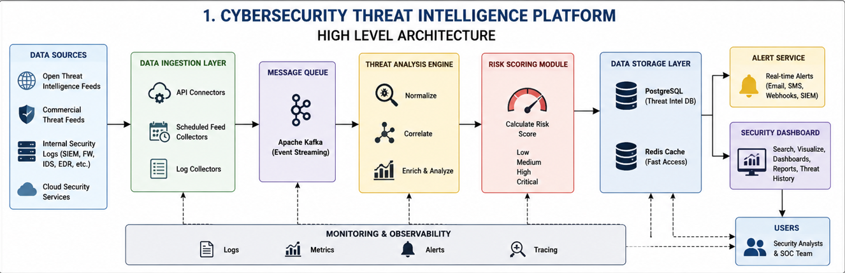

EMERGENCY DISASTER RESPONSE SYSTEM
(HIGH LEVEL ARCHITECTUTRE)

